**Wednesday 17th July**

Dear Parents and Carers

I am writing to you to inform you of some of the changes that will be taking place over the summer and also some the changes that will be implemented when we return in September.

As I’m sure you are aware the school has grown considerably over the past couple of years which has necessitated some changes to the school buildings and the space outside the school. From September all of the primary pupils except Oak and Maple will have a classroom on the top field, work has begun on building these portakabin classrooms last week with groundworks being put in place in preparation for the rooms being available from September. The first part of the development in shown in the diagram below. In future developments both classes will move into this area of school as well. If your child is in Year 6 they will be in classroom A or B, Year 5 and Year 4 will be in classroom C and D and if your child is in Year 4 they will be in classroom E.

Beech

Elder

Rowan

Hazel

Birch

This will be called the primary village and we have been informed that it will be completed by the end of August. Staff are working hard this week and next to transfer all the equipment and resources to the portakabins. As well as investing in the buildings themselves there will be huge investment in the facilities that are on offer for the pupils. We have investigated different play equipment and prices as well as seeking views from pupils and parents and have decided on the design shown below. This will in a play are in the middle of the classrooms and is due to be completed by the end of September/beginning of October.

This is a truly unique opportunity to develop the school and provide them with the opportunities the deserve and we are all so excited by the developments that are taking place over the next six months.

To the rear of the school there will be a vocational area where pupils will continue to develop their skills in motor vehicle maintenance, bricklaying, construction, plastering, and painting and decorating. The map below shows where this will be located and the artists impression is also shown.

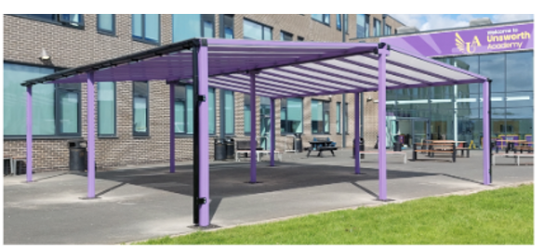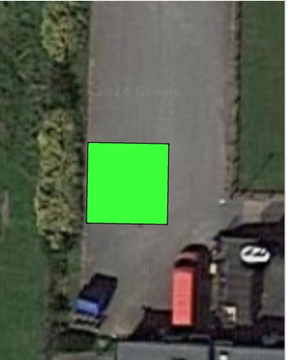 The final development will be here at the back of school and will be called the ‘Book Nook’ pupils will be able to take reading books into the nook, which has a fire pit and wood burning stove, this will also be used for wellbeing sessions and for pupils to self-regulate.

The primary classes that used to be in the main building will now all become secondary classrooms.

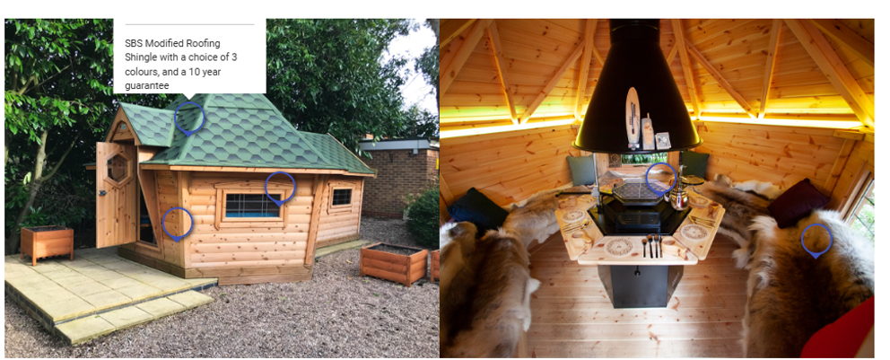

There are lots of changes happening and we hope to have all of these in place for the Christmas holidays, as I’m sure you can imagine, these changes are going to make a huge difference to the educational experiences that pupils will have at Croft.

**Practical changes.**

**Lunch time**

To accommodate the changes in numbers at Croft, there are 262 pupils on roll for September we are changing the lunchtimes. From September primary pupils will be eating lunch in the dining hall in the main body of school between 12:00 and 12:25.

Secondary pupils will return to form classes at 12:00 and take part in their reading time as well as register for the afternoon. Their active 30 time will begin at 12:25 with the three sittings continuing for eating and the other 40 minutes taking part in physical activity. Start and finish times of the school day remain the same.

**Yards**

From September the primary pupils will be using the play area and the top yard, all secondary pupils will be on the MUGAS at the back of the school where there will be a choice of quiet yard or active yard. They will still be able to access the sports hall and dance clubs as well as the other lunchtime activities.

**End of school day**

At the end of school instead of pupils returning to their pastoral classes they will be placed in taxi/bus groups in various classrooms where they will be then be escorted by class staff to the buses, Hopefully this will speed up the exit of pupils at the end of the school day.

**Appointments**

We have recently appointed 5 new learning support assistants to work across the school, these are Mr Malloy, Miss Clark, Miss Allen, Miss Webster and Miss Wilkinson. We have also appointed Mr Coutakis to teach PE in secondary and Miss Chum and Miss Brannan to teach in Primary. We are also seeking to appoint a new Maths teacher, and an English teacher and these appointments will follow in the future.

**Goodbyes**

We also have to say good luck and goodbye to staff who have been at Croft a long time. Mr Vernon is leaving us to become a senior leader in a school in Blyth, Miss Clark is of to teach in Sunderland, and Mr Walker is retiring after a long and distinguished career, we wish all three members of staff a positive experience in their new schools and to Mr Walker a very happy and well deserved retirement.

**End of Year reports**

These are being printed this week and will be sent home on the 22nd July.

**Attendance**

There is a huge emphasis on improving school attendance and we have sent letters home explaining the new system, we really need to emphasise that from September we will be authoring very few absences and it must be exceptional circumstances in order for this to happen. While sympathetic to the needs of our pupils we are following instructions for the local authority.

**School holidays.**

Finally, on behalf of all the staff we just wanted to say thank you for all of your support over the past year, it is very much appreciated, the school has continued to grow which has presented its own challenges but taking that as a positive it must mean we are doing something right! We know how precious your children are to you and we thank you for placing your trust in us to educate them, support them and help them to grow, intellectually and emotionally.

Have a lovely break and we will see you in September, in the meantime if you have any questions about any of the information above please don’t hesitate to get in touch.

Yours Sincerely

Lee Davis

Head of School.