RE is based on:
*Knowledge and Understanding of Religion * Critical Thinking * Personal Reflection
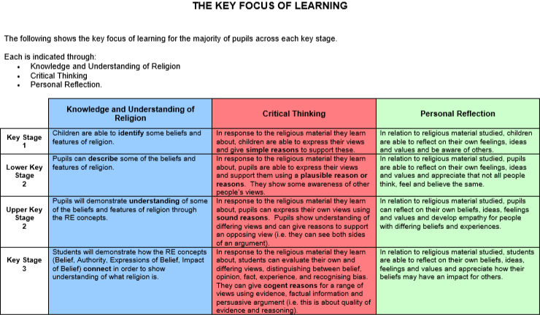
These are interlinked and enable pupils to make good progress in RE

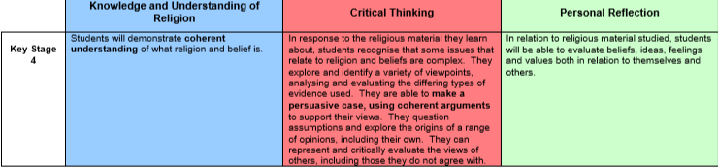
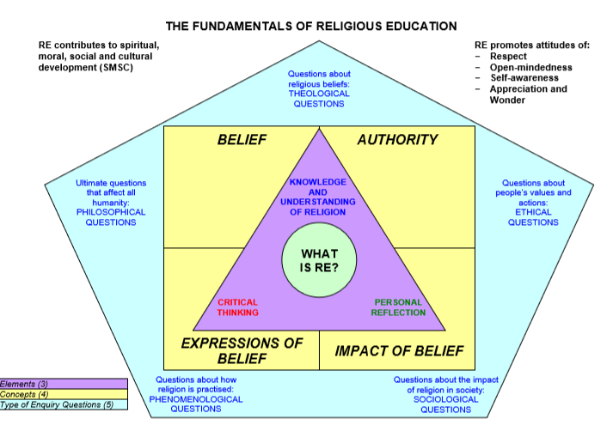

 | Autumn | SpringTerm | Summer Term
Y1 | 1. What can we learn about Christianity from visiting a church? What do Christians believe about God?  Divali- a special time for Hindus  Raksha Bandhan  2.Christianity- Why are gifts given at christmas? | 1.Christianity-Special people- Jesus for Christians. Why is Jesus special to Christians?  Introduce Jesus, beliefs and stories about Jesus.Belief and Authority.  Stories about Jesus- calming the storm, walking on water  2.Easter- The Easter storyStory  How Christians celebrate in church eg Easter Garden  ‘Badger's Parting Gifts’ by Susan Varley | 1.What can we find out about Buddha?  2.Christianity- A Christian wedding  A Christian Baptism
Y2 | 1. Why is the Bible special to Christians?  What can we learn from the story of St Cuthbert  2. How and why is light important at Christmas? | 1.What can we learn about Christian worship and beliefs by visiting churches?  What does it mean to belong in Christianity?  2. How do Christians celebrate Easter? | 1.How do Buddhists show their beliefs?  2.What can we learn about our local faith communities?
Y3 | 1.How do Hindus worship?  2. How and why is Advent imprtant to Christians? | 1 Judaism- What does it mean to belong in Judaism? Including worship, ceremonies and how commitment & belonging is shown (expression & impact of belief)  2.Easter-How do Christians celebrate Easter? What do Christians remember on Palm Sunday | 1 What do Hindus believe?  2. What can we learn about our local faith community? Exploring and visiting local religious settings
Y4 | What do we know about the biblle and why is it special to Christians? Introduce beliefs about God shown in the bible: Belief, Authority, Expressions of belief  2. How & why light is important at Christmas? Why do Christians call Jesus the light of the world?  Jesus the light of the world, Christingle | 1. What do Christians believe about Jesus. Stories from the new Testement.  2. Why is Lent such an important period for Christians? | 1.How do people show care for others? Explore at least two religions.  2.Why do people visit Durham Cathederal today? Visit. Why do people travel to sacred places? (exploration through the four concepts)
Y5 | 1. Why is Moses important to Jewish people? Stories about Moses, The baby in the basket, The burning bush and The escape from Egypt.  Why do Jewish people go to the synagogue?  2.Christianity- What are the themes of Christmas? Secular and non-secular, Should non Christians have Christmas? Debate. | 1. What do Christians believe about God?  2.Easter- Why is the Last Supper so important to Christians? The events leading up to the crucifixion Food as part of Christian worship. Judas- the betrayal. | 1. How are Jewish beliefs expressed in the home?  Demonstrate an understanding of what a day in the life of a Jewish child is like, how this impacts on thier life and what we have in common and how they differ.  Belief, Expression, authority and impact of belief.  2. Why do people use rituals today?
Y6 | 1.What can we learn about religious diversity in our area?  What can we find out about a local Muslim community?  2. What do the gospels tell us about the birth of Jesus? | 1 How and why do people care about the environment? Demonstrating understanding of the impact of religious faiths on actions:impact of belief  2. Why are Good Friday and Easter Day the most important days for Christians? | 1. So what do we now know about Christianity?  (through the four concepts)  2. Bridging Unit (statutory)

Hinduism (Dwalli) in the week of NOV 6th Rama & Sita story (primary)
KS3  Year 7 | 1.Statutory bridging unit-  Can we define religion?  (How do the RE concepts help us to understand religion?) Belief, Authority, Expressions of belief, impact of belief  2.Why do some people believe in God?  Explore more than one religion (Include Christainity and Budhhism)  Do religions bring conflict or harmony?  Can miracles happen? | 1 Judaism- what does it mean to live as a Jew in the North East today? Where did the religion originate? Persicution of Jewish people overtime  What do religions say about good, evil and suffering?  2. How are the arts used to express religious belief and spirituality?  How do people express themselves through art? Buddhism, Christianity, Hinduism and Islam. | 1. Should religious people get involved in wars?  Investigate current news on conflict that is religion based. Gather information, debate, decide and give reasons for opinions.  2. How do the beliefs of Sikhs affect their daily lives and actions?  Beliefs and practices, including diversity within and across different traditions and communities, the impact of these for different indivisuals, communities and societies
Year 8 | 1.Can we draw the Big Picture of Christianity?  What are the beliefs of Christians and what impact might these have on individuals and communities today?  What might bring communities together or divide them?  2.What are the various reasons why people might belong to a religion?  Birth, reasons for change of religion, belif from a child to adult  What does it mean to live in a religiously diverse country?  What religions do you know about? Where does authority lie in religions? | 1. Is death the end? How do religions reflect beliefs about life after death?  Explore at least three (Christianity, Hinduism and Buddhism) religious beliefs and compare, share and discuss. Give opinions and reasons for them.  2.Can religion and science mix?  Discuss, debate, evidence to form an opinion | 1. What does it mean to live as a Muslim in Britain today?  News, opinions and facts. Fair/unfair?  2. How does media portray religion?  Explore stereotyping and portrayal through television, newspapers and the internet
Year 9 | 1.What does it mean to live as a Humanist?  What is Humanism? What are the key beliefs of Humanism?  2.How and why do some people with a religious faith get involved with politics?  Extreme views, identification. What is faith, what is politics, research to debate the main question, evidence and form an opinion with reasons. | 1.How might people of faith make moral decisions?  What is a moral decision? Guidance for life decisions, crime, sex before marriage, abortion etc What would a Jehovahs witness or person of another faith do when a loved on needed a blood transfusion?  2.What does justice mean for people with a religious faith today?  What is justice and how do different religions see it? Justice, truth and peace. | 1.What does it mean to live as a Buddhist in Britain today?  Celebrations, beliefs  What do religions say about good, evil and suffering?  2.Is religion relevant in our world today?  Identity, meaning of life, does age make a difference?  Discuss, debate, evidence to form an opinion
KS4 Static class  B&V  Y10 | AQA unit awards  1.Introduction to the Six Major Religions  2.Comparing Three Religions and Their Religious Festivals | AQA unit awards  1.Christianity  2. Religion and Science – Creation | AQA unit awards  1.Islam  2.Islamic and Christian views on peace and conflict
KS4 Static class  B&V  Y11 | AQA unit awards  1.Hinduism  2.Different Faith Traditions within a Contemporary Society | AQA unit awards  1.Buddhism  2. Crime and punishment | AQA unit awards  1.Humanism
KS4  Y10  ASDAN  B&V short course | Module 1 – Values, beliefs and decision making  The aim of this module is to develop understanding of personal qualities, values and beliefs, and the role they play in decision making. It provides opportunities to learn about how these values contribute to our diverse and multiciltural society/ | Module 2 – Environment  The aim of this module is to develop understanding of the significant impact that we have on the environment and how to take responsibility for our actions. It provides opportunities to learn about issues such as sustainability, animals rights and renewable energy. | Module 3 – Crime and punishment  The aim of this module is to deveop understand of what it means to be a responsible citizen and the laws necessary for society to function justly and fairly. It provides opportunities to learn about issues such as bullying, prejudice, discrimination and persecution.
KS4  Y11  ASDAN  B&V short course | Module 4 – Peace and conflict  The aim of this module is to develop understanding of the value of peace in society and the impact of conflict. It provides opportunities to lean about issues such as the role of the armed forces, pacifism and weapons of mass destruction. | Module 5 – Beliefs and practice  The aim of the module is to develop understanding of different religions and how they express their beliefs through worship and actions. It provides opportunities to learn about topics such as pilgrimage, ceremonies, places of worship and non-religious beliefs. | Module 6 – Inspiration  The aim of this module is to develop understanding of inspiration as a religious and non-religious experience. It provides opportunities to learn about different sources of inspiration, such as music, art, nature and other people.
KS4  Y10  AQA RE short course | 1.Christianity  What are the beliefs, teachings and pracitices of Christianity and how do they infuence individuals, communities and societies?  2.Relationshipships and families  How might people faith make decisions regarding sex, marriage and divorce?  How might faith impact a persons views on families and gender equality? | 1.Relationships and families  How might people faith make decisions regarding sex, marriage and divorce?  How might faith impact a persons views on families and gender equality?  2.Religion, peace and conflict  Religion, violence, terrorism and war  Religion and belief in 21st century conflict | 1.Religion, peace and conflict  Religion, violence, terrorism and war  Religion and belief in 21st century conflict  2. AQA unit awards  Hinduism
KS4  Y11  AQA RE short course | 1.Buddhism  What are the beliefs, teachings and pracitices of Buddhism and how do they infuence individuals, communities and societies?  All short course covered by Feb half term latest if anyone wants to do GCSE | AQA unit awards  1.Humanism  2. Crime and punishment | AQA unit awards  1. Different Faith Traditions within a Contemporary Society

