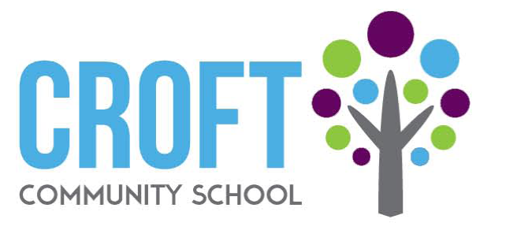

**Long Term Planning Framework – NOCN Entry Level Certificate in Vocational Studies (Entry 3)**

**Key Stage 4: 2023-2024**

|  |  |  |  |  |  |  |  |
| --- | --- | --- | --- | --- | --- | --- | --- |
| **Class** | Term 1 |  | **Class** | Term 2 |  | **Class** | Term 3 |
| **Year 10** | **Introduction to catering**  **Level:** Entry level 3  **Credit value**: 3  **Reference**: T/505/0591  **Guided learning hours**: 30  1. Know duties, procedures and requirements relevant to own role in catering.  2 Know about equipment used when working in catering.  3 Know health and safety procedures for working in a catering workplace.  4 Be able to communicate with others when working in catering. |  | **Year 10** | **Prepare and cook: fish, meat and poultry.**  **Reference:** F/505/0593  **Level:** Entry Level 3  **Credit Value:** 3  **Guided Learning Hours:** 30  1 Know about some common types of fish, meat and poultry.  2 Know how to prepare fish, meat and poultry.  3 Know how to cook fish, meat and poultry. |  | **Year 10** | **Making and storing baked products**  **Reference**: A/505/0592  **Level:** Entry Level 3  **Credit Value:** 3  **Guided Learning Hours**: 30   1. Know preparation methods for baked products.   2. Be able to follow recipes for baked products.  3. Be able to store baked products. |
| **Year 11** | **Introduction to catering**  **Level:** Entry level 3  **Credit value:** 3  **Reference:** T/505/0591  **Guided learning hours:**30  1. Know duties, procedures and requirements relevant to own role in catering.  2 Know about equipment used when working in catering.  3 Know health and safety procedures for working in a catering workplace.  4 Be able to communicate with others when working in catering.  **Prepare and cook: fish, meat and poultry.**  **Reference:** F/505/0593  **Level:** Entry Level 3  **Credit Value:** 3  **Guided Learning Hours**: 30  1 Know about some common types of fish, meat and poultry.  2 Know how to prepare fish, meat and poultry.  3 Know how to cook fish, meat and poultry. |  | **Year 11** | **Making and storing baked products**  **Reference**: A/505/0592  **Level:** Entry Level 3  **Credit Value:** 3  **Guided Learning Hours:** 30   1. Know preparation methods for baked products.   2. Be able to follow recipes for baked products.  3. Be able to store baked products.  **Food service**  (1.1) describe different types of food service  (2.1) State health and safety requirements when serving food  (2.2) Serve hot/cold food, including plated and counter service in a safe and hygienic manner.  (3.1) Set up, maintain and close down the service area according to instructions. |  | **Year 11** | **Customer service skills**  **Reference**: H/505/0392  **Level:** Entry Level 3  **Credit Value**: 2  **Guided Learning Hours**: 20  1 Understand the benefits of good customer service to an organisation.  2 Understand the possible consequences of poor customer service.  3 Understand the importance of first impressions.  4 Know how to assist customers.  **Basic food preparation and cooking**  (1.1) state the principal methods of cooking  (1.2) state different cooking methods for different commodities  (2.1) prepare, cook and present simple dishes safely and hygienically using wet and dry methods.  (2.2) clean work areas and equipment safely and hygienically during and after preparing and cooking food.  (2.3) State safe working practices for different cooking methods  (2.4) review own performance and make suggestions for future improvements |