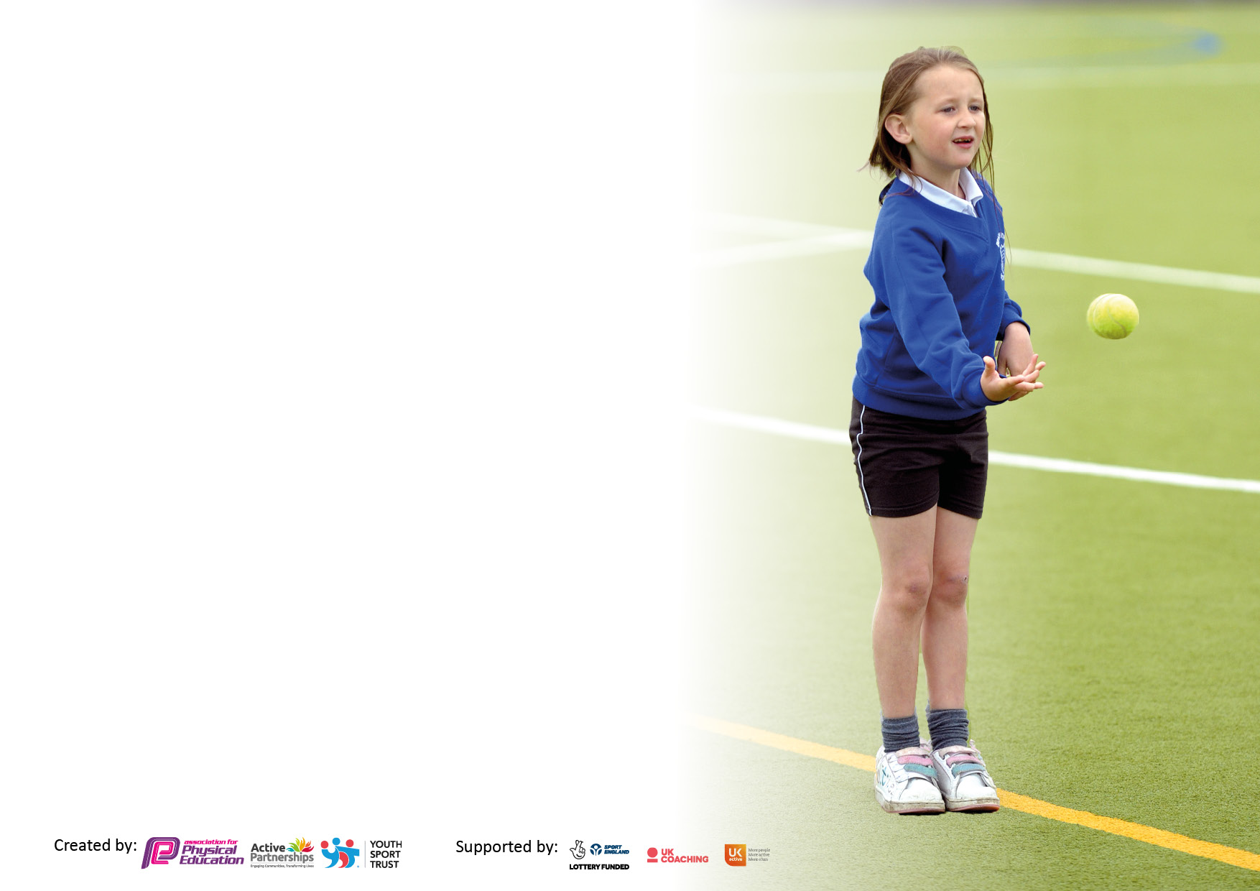

It is important that your grant is used effectively and based on school need. The [Education Inspection Framework](https://www.gov.uk/government/publications/education-inspection-framework) makes clear there will be a focus on **‘whether leaders and those responsible for governors all understand their respective roles and perform these in a way that enhances the effectiveness of the school’**.

Under the Quality of Education judgement, Ofsted inspectors consider:

**Intent** - Curriculum design, coverage and appropriateness

**Implementation** - Curriculum delivery, teaching (pedagogy) and assessment

**Impact** - Attainment and progress

To assist schools with common transferable language, this template has been developed to utilise the same three headings which should make your plans easily transferable between working documents.

Schools must use the funding to make additional and sustainable improvements to the quality of Physical Education, School Sport and Physical Activity (PESSPA) they offer. This means that you should use the Primary PE and sport premium to:

* Develop or add to the PESSPA activities that your school already offers
* Build capacity and capability within the school to ensure that improvements made now will benefit pupils joining the school in future years
* The Primary PE and sport premium should not be used to fund capital spend projects; the school’s budget should fund these.

Please visit <https://www.gov.uk/guidance/pe-and-sport-premium-for-primary-schools> for the revised DfE guidance, including the 5 key indicators across which schools should demonstrate an improvement. This document will help you to review your provision and to report your spend. DfE encourages schools to use this template as an effective way of meeting the reporting requirements of the Primary PE and Sport Premium.

We recommend you start by reflecting on the impact of current provision and reviewing the previous spend.

Schools are required to publish details of how they spend this funding, including any underspend from 2021/2022, as well as on the impact it has on pupils’ PE and sport participation and attainment.

We recommend regularly updating the table and publishing it on your website throughout the year. This evidences your ongoing self-evaluation of how you are using the funding to secure maximum, sustainable impact. Final copy must be posted on your website by the end of the academic year and no later than the 31 July 2023.

**Details with regard to funding**

Please complete the table below.

|  |  |
| --- | --- |
| Total amount carried over from 2022/23 | £0 |
| Total amount allocated for 2023/24 | £16,547.00 |
| How much (if any) do you intend to carry over from this total fund into 2023/24? | £0 |
| Total amount allocated for 2023/24 | £16.547.00 |
| Total amount of funding for 2023/24 to be reported on by 31st July 2024 | £ 16,547.00 |

**Swimming Data**

Please report on your Swimming Data below.

|  |  |
| --- | --- |
| Meeting national curriculum requirements for swimming and water safety.  **N.B.** Complete this section as best you can. For example, you might have practised safe self-rescue techniques on dry land which you can then transfer to the pool when school swimming restarts.  **Due to exceptional circumstances priority should be given to ensuring that pupils can perform safe self-rescue even if they do not fully meet the first two requirements of the NC programme of study** |  |
| What percentage of your current Year 6 cohort swim competently, confidently and proficiently over a distance of at least 25 metres?  **N.B.** Even though your pupils may swim in another year, please report on their attainment on leaving primary school at the end of the summer term 2023.  Please see note above | 30% |
| What percentage of your current Year 6 cohort use a range of strokes effectively [for example, front crawl, backstroke and breaststroke]?  Please see note above | 30% |
| What percentage of your current Year 6 cohort perform safe self-rescue in different water-based situations? | 0% |
| Schools can choose to use the Primary PE and sport premium to provide additional provision for swimming, but this must be for activity **over and above** the national curriculum requirements. Have you used it in this way? | Yes/No |

**Action Plan and Budget Tracking**

Capture your intended annual spend against the 5 key indicators. Clarify the success criteria and evidence of impact that you intend to measure to evaluate for pupils today and for the future.

|  |  |  |  |  |
| --- | --- | --- | --- | --- |
| **Academic Year:** 2023/24 | **Total fund allocated:** | **Date Updated:** | |  |
| **Key indicator 1:** Increase confidence, knowledge and skills of all staff in teaching PE and sport | | | | Percentage of total allocation: |
| 1.3% |
| **Intent** | **Implementation** | | **Impact** |  |
| Your school focus should be clear on what you want the pupils to know and be able to do. What do they need to learn and to consolidate through practice: | Make sure your actions to achieve are linked to your intentions: | Funding allocated: | Evidence of impact:  What do pupils now know and what can they now do? What has changed? | Sustainability and suggested next steps: |
| To ensure all pupils are able to access the dance curriculum and benefit from after school provision. | Purchasing Spotify for the year to be used throughout primary. | £215.88 | Staff are able to deliver lessons and develop pupil’s knowledge and skills.  Pupils have engaged in after school clubs during the Summer term and parent’s/carers have commented on how useful this offer has been, including for the social benefits to pupils who are isolated. | This subscription to be continued each year to ensure all pupils have opportunities to access the dance curriculum. |
| **Key indicator 2:** The engagement of all pupils in regular physical activity – Chief Medical Officers’ guidelines recommend that  primary school pupils undertake at least 30 minutes of physical activity a day in school | | | | Percentage of total allocation: |
| 31% |
| **Intent** | **Implementation** | | **Impact** |  |
| Your school focus should be clear on what you want the pupils to know and be able to do. What do they need to learn and to consolidate through practice: | Make sure your actions to achieve are linked to your intentions: | Funding allocated: | Evidence of impact:  What do pupils now know and what can they now do? What has changed? | Sustainability and suggested next steps: |
| To promote daily active blasts and active maths lessons at least once a week. | Purchasing imoves – Active 30 bundle to support active blasts and lessons throughout the day to provide pupils with at least 30 minutes of Physical activity along with playtimes. | £649.00 | To increase fitness and physical activity levels in all children to combat childhood obesity and meet Durham County target of at least 30 mins of physical activity each day.  Pupils are engaged and enthusiastic to take part in I moves sessions which are exciting, motivating and have contributed to the Active 30 across the day. | To be renewed next year at a cost of £649. |
| To promote PESSPA and increase physical activity in students. To offer a wide variety of opportunities for physical activity. | Purchase a storage unit to ensure equipment is safe and secure so pupils can access it daily. | £2520 (TTS) | To increase fitness and physical activity levels in all children to combat childhood obesity and meet Durham County target of at least 30 mins of physical activity each day. Pupils are engaged in physical activities during playtime and are exposed to a variety of sports which they engage in. Behaviour is good and there are less incidents on the yard due to staff leading groups.  Waiting for delivery onto new primary yard. | Ongoing, to renew any damaged equipment or additional equipment for new groups. |
| To increase physical activity, gain water confidence and, by Year 6 swim 25 meters. | Purchase additional swimming sessions for all primary school children across the year. | £2,000.00 | Pupils across primary swim across the year and experience water to gain confidence  All KS2 pupils have attended swimming lessons across the year, 30% gaining their 25meters in Year 6.  The school gained the ‘Water Smart’ GOLD accreditation this year from The Royal Life Saving Society UK and has plans to join in with swimming Gala’s in the coming year to maintain this. | To look at the Swimphany data in the summer term to see the percentage of pupils who have made progress in water confidence and purchase additional sessions for next year to target those who have potential to reach 25m by year 6. |

|  |  |  |  |  |
| --- | --- | --- | --- | --- |
| **Key indicator 3:** The profile of PE and sport is raised across the school as a tool for whole school improvement | | | | Percentage of total allocation: |
| 14% |
| **Intent** | **Implementation** | | **Impact** |  |
| Your school focus should be clear on what you want the pupils to know and be able to do. What do they need to learn and to consolidate through practice: | Make sure your actions to achieve are linked to your intentions: | Funding allocated: | Evidence of impact:  What do pupils now know and what can they now do? What has  changed? | Sustainability and suggested next steps: |
|  |  |  |  |  |
|  |  |  |  |  |
|  |  |  |  |  |
|  |  |  |  |  |
| To support development across PE, being able to evidence and assess lessons effectively. | Purchasing 4 iPads to be used for PE lessons, to evidence work, assess and have access to music throughout the curriculum. | £1060.00 | Assessment of progression and knowledge recorded and monitored. Pupils can self-assess through watching recordings of themselves during physical activity.  Evidence for Learning is used to record progress, assess and collate reports in PE across the school. Parents and pupils have said they enjoy looking at progress this way, and this is an effective, precise way to monitor curriculum delivery. | Continued use across primary |
| To continue use of the sports hall and ensure all classes access at least two physical education lessons per week. | Purchasing a new dividing curtain for the sports hall. | £1,265.00 | Pupils access the sports hall for lessons and additional PESSPA sessions. The curtain divides the hall into two large areas where two different sports activities can run simultaneously.  All pupils access the sports hall for two PE lessons per week, apart from the swimming group who rotate. | Curtain to be checked and maintained to a high standard. |
| **Key indicator 4:** Broader experience of a range of sports and physical activities offered to all pupils | | | | Percentage of total allocation: |
| 11.4% |
| **Intent** | **Implementation** | | **Impact** |  |
| Your school focus should be clear on what you want the pupils to know and be able to do. What do they need to learn and to consolidate through practice: | Make sure your actions to achieve are linked to your intentions: | Funding allocated: | Evidence of impact:  What do pupils now know and what can they now do? What has  changed? | Sustainability and suggested next steps: |
|  |  |  |  |  |
|  |  |  |  |  |
|  |  |  |  |  |
|  |  |  |  |  |
| For all pupils in EYFS/KS1/KS2 to continue to access a broad and balanced curriculum that will prepare them for KS3 PE curriculum.  Broadening activity ideas for staff to teach. | Renewal of Primary PE planning membership – continued from previous year. | £395 | Staff confident with planning for the different key stages, recognising progression and expanding activity ideas.  Resources and planning is provided to inspire teachers, explain concepts and during staff absence teaching can still go ahead. | An increase in staff confidence leads to greater participation by students and improved teaching and learning. |
| To ensure all pupils can participate in swimming sessions. | Purchase adult armbands for older/bigger primary pupils. X10 | £79.90 | Pupils who require swimming aids can now access the pool safely with no issues about floats not fitting.  Pupils who are in year 5/6 but are non-swimmers can access the pool with floats that fit their arms now. They are confident to enter the pool and have made progress in water confidence, assessed on Swimphony. | Students who were previously unable to access swimming lessons are now engaging with swimming; a lifelong skill. |
| To ensure all pupils can join in gymnastic activities and attempt forward and backward rolls with assistance. | Gymnastics equipment, Springboard and surround mats. | £605.98 | Pupils who are less flexible can access lessons with the support of the springboard and guidance from staff.  This equipment will be used in the Autumn term where gymnastics is delivered across the curriculum. | This equipment will be used yearly in the Autumn term, across all primary year groups. |

|  |  |  |  |  |
| --- | --- | --- | --- | --- |
| **Key indicator 5:** Increased participation in competitive sport | | | | Percentage of total allocation: |
| 11.1% |
| **Intent** | **Implementation** | | **Impact** |  |
| Your school focus should be clear on what you want the pupils to know and be able to do. What do they need to learn and to consolidate through practice: | Make sure your actions to achieve are linked to your intentions: | Funding allocated: | Evidence of impact:  What do pupils now know and what can they now do? What has  changed? | Sustainability and suggested next steps: |
|  |  |  |  |  |
|  |  |  |  |  |
|  |  |  |  |  |
|  |  |  |  |  |
| To access competitive festivals and competitions arranged by the SLP. | To provide pupils with a chance to compete in competitive sports and festivals within the local area. | £1850 | Each class across primary joined in with different festivals both at venues and virtual.  Pupils across primary have taken part in sporting events with local primary schools, like multi sports, gymnastics and cricket.  Due to refurbishment of the Louisa Centre, some events were cancelled, the full SLP events Calander will run from September. We have an additional offer of Boxing coaching (for free) from ‘Thrive’ at the Louisa Centre who will come into school. | By students participating in competitive sports, confidence has increased and students have formed teams to compete against other schools. |

|  |  |
| --- | --- |
| Signed off by **TOTAL- £10,640.76** | |
| Assistant Head Teacher: | Rachel Ridley |
| Date: | 1.7.24 |
| Subject Leader: | Laurie Robson |
| Date: | 22.4.24 |
| Governor: |  |
| Date: |  |